**ECE 430**

**Laura and Joshua**

**Radio Wars E3**

**Procedure:**

[describe how we implemented synchronization to our frequency hopping]

[add screenshot of updated ‘frequency hopping’ function]

**Results:**

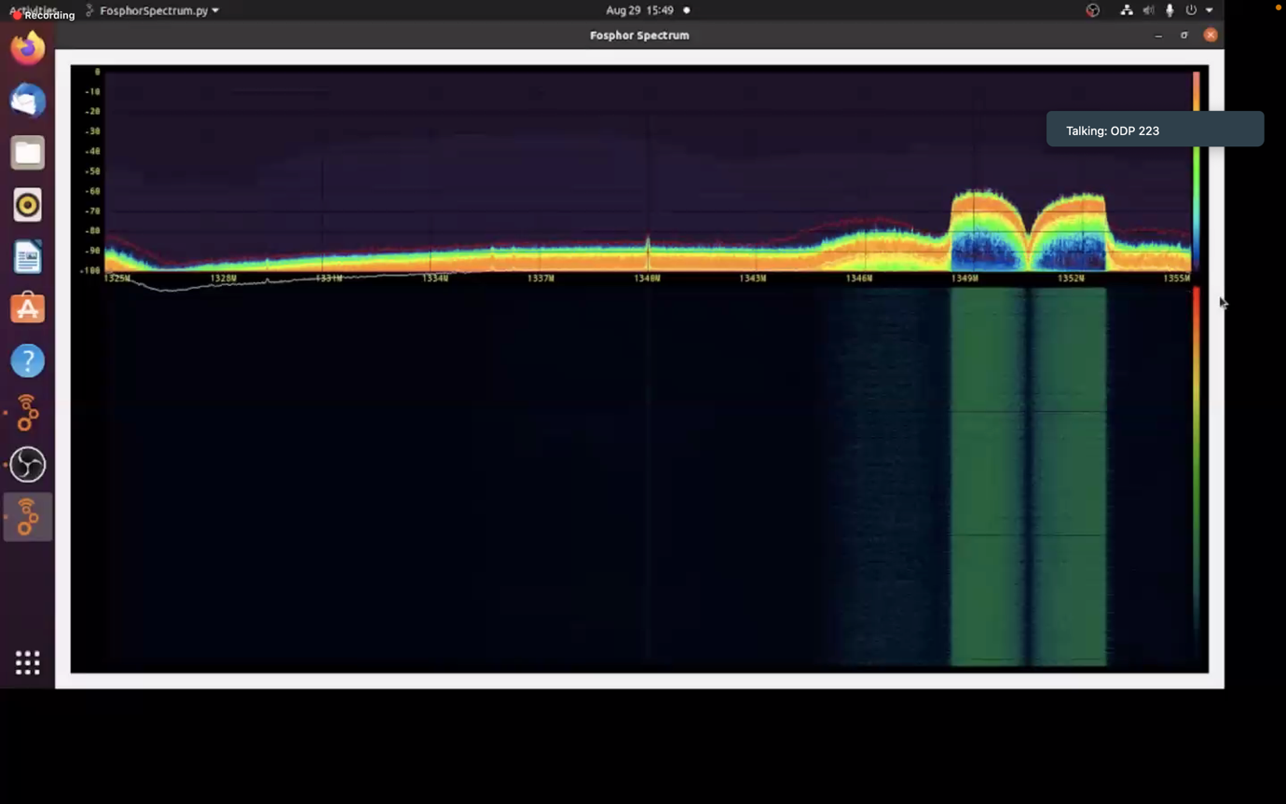**Figure 1:** Transmission with no jammer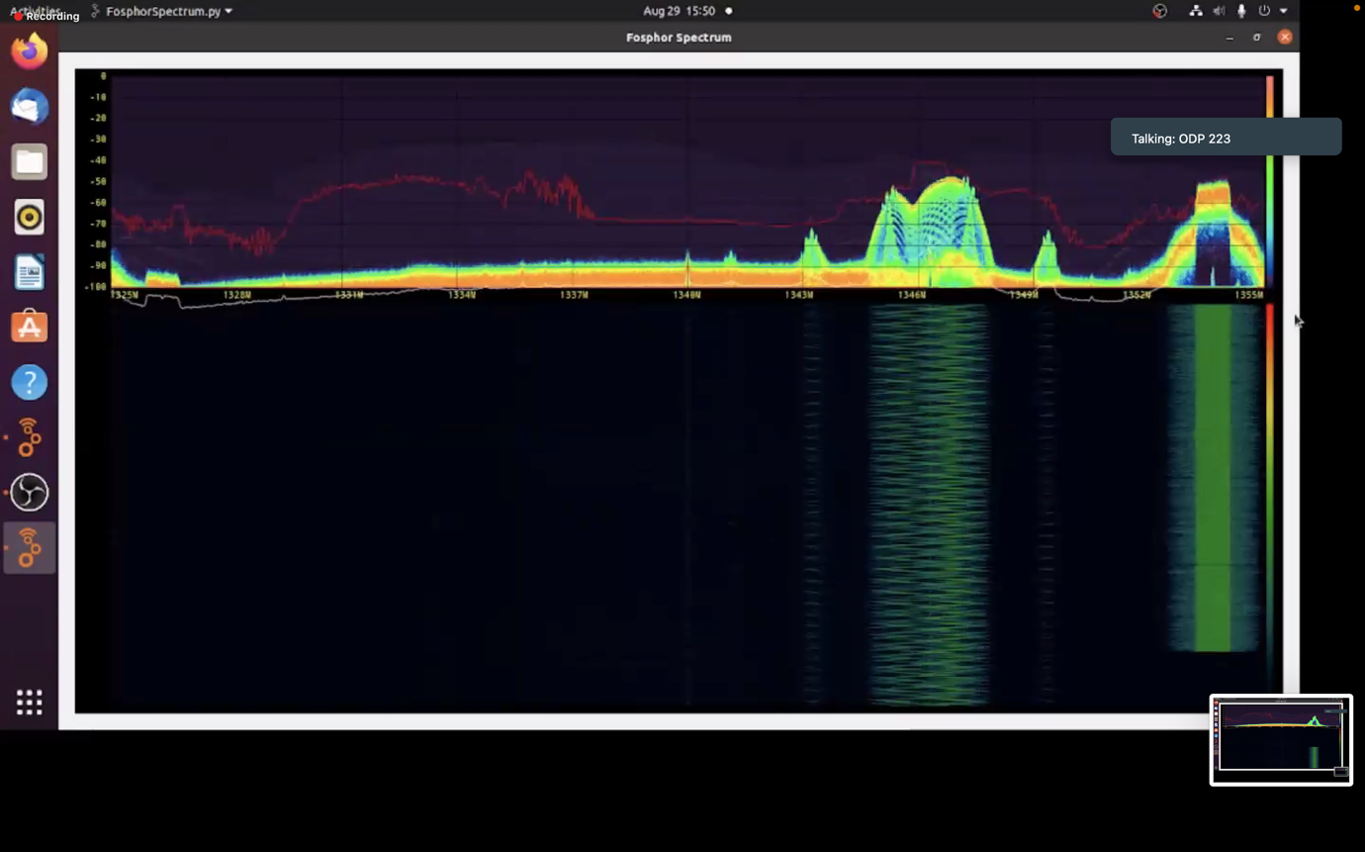**Figure 2:** Transmission interrupted by jammer



**Figure 3:** Radio wars submission